Decision 01-09-008 September 6, 2001

BEFORE THE PUBLIC UTILITIES COMMISSION OF THE STATE OF CALIFORNIA

Application of the North San Diego County Transit Development Board for an order authorizing construction of two Standard No. 8 Flashers pursuant to CPUC General Order No. 75-C, with low-tone bells, baffles and back to back roundels, at the existing concrete in-station pedestrian at-grade crossing at the Carlsbad Village Commuter Rail Station. | Application 01-05-005  (Filed May 2, 2001)
Application of the North San Diego County Transit Development Board for an order authorizing construction of two (2) Standard No. 8 Flashers pursuant to CPUC General Order No. 75-C, with low-tone bells, baffles and back to back roundels, at each existing concrete in-station pedestrian at-grade crossing at the Carlsbad Poinsettia Rail Station. | Application 01-05-006  (Filed May 2, 2001)
Application of the North San Diego County Transit Development Board for an order authorizing the construction of two (2) Standard No. 8 Flashers pursuant to CPUC General Order No. 75-C, with low-tone bells, baffles and back to back roundels, at the existing concrete in-station pedestrian at-grade crossing at the Encinitas Commuter Rail Station. | Application 01-05-007  (Filed May 2, 2001)

Application of the North San Diego County Transit Development Board for an order authorizing the construction of two (2) Standard No. 8 Flashers pursuant to CPUC General Order No. 75-C, with low-tone bells and back to back roundels, and the replacement of existing pavement with concrete crossing material, at an existing in-station pedestrian at-grade crossing, and the construction of a new in-station crossing, with two (2) Standard No. 8 Flashers, pursuant to CPUC General Order No. 75-C, with low-tone bells and back to back roundels, and concrete crossing material, at the Sorrento Valley Commuter Rail Station. | Application 01-05-008  (Filed May 2, 2001)

OPINION

Summary
North San Diego County Transit Development Board (NCTD) requests authority to install automatic signal warning devices to enhance safety of existing concrete in-station pedestrian at-grade crossings at various locations, as more fully described in Applications 01-05-005, 01-05-006, 01-05-007 and 01-05-008 all within San Diego County. Because they raise related factual and legal issues, the applications have been consolidated for decision-making purposes (Rule 55).

Discussion
North San Diego County Transit Development Board (NCTD) is a transit development board existing under Sections 125000 et seq. of the Public Utilities Code of the State of California. NCTD is charged with the construction and operation of public transit systems within its area of jurisdiction and is the owner of certain railroad right-of-way assets from the Orange County/San Diego County line to the City of San Diego, California (milepost 207.41 to milepost 245.59).
As part of a project to enhance safety of existing concrete in-station pedestrian at-grade crossings, NCTD proposes to install automatic signal warning devices at various commuter rail stations within San Diego County, as listed below:
1. The Carlsbad Village Commuter Rail Station is located in downtown Carlsbad in a predominately commercial area.
2. The Carlsbad Poinsettia Rail Station is located in the City of Carlsbad in a mixed residential/commercial area.
3. The Encinitas Commuter Rail Station is located in downtown Encinitas in a predominantly commercial area.
4. The Sorrento Valley Commuter Rail Station is located in the City of San Diego in the center of a large industrial area, alongside Sorrento Valley Road and under an Interstate 5 Freeway overpass.
NCTD seeks approval from the Commission to install automatic warning devices, as more fully indicated by plans shown in Appendix A, pages 1 to 4 and as described by Appendix B, pages 1 to 4.
NCTD is the lead agency for this project under the California Environmental Quality Act of 1970 (CEQA), as amended, Public Resources (PR) Code Sections 21000, et seq. The project has a CEQA statutory exemption under Section 21080 B.b)(10) of the Public Resources Code. The California Coastal Commission has also determined that the project is exempt from its permit requirements of the Coastal Act and issued an Exemption Letter on September 27, 2000. On October 30, 2000, NCTD filed a Notice of Exemption with the San Diego County Clerk.
The Commission is a responsible agency for this project under CEQA and has reviewed and considered NCTD’S environmental documentation. Under Rule 17.1 Preparation and Submission of Environmental Impact Reports, of the Commission’s Rules of Practice and Procedure, Section (h) Categorical Exemptions:
- The following specific projects are within the classes of projects which the Secretary for Resources has exempted from the EIR requirements of CEQA:
- Class 1 Exemptions.
Item 7. Installation of new railroad-highway signals or signs.

The installation of railroad-highway signals to enhance the safety of pedestrians at the commuter stations as requested by NCTD qualify as categorically exempt from the Environmental Impact Report (EIR) requirements of CEQA.
The sites of the proposed projects have been inspected by the Commission's Rail Safety and Carrier Division – Rail Crossings Engineering Section staff. Staff examined the need for and the safety of the proposed installation of automatic signals, and recommends that the applications be approved.
The applications were found to be in compliance with the Commission's filing requirements, including Rules 38 to 41 of the Rules of Practice and Procedure. Site maps of the pedestrian at-grade crossings are as shown on plans attached to the applications and appendix A.
In Resolution ALJ 176-3063, dated May 14, 2001 and published on the Commission Daily Calendar on May 15, 2001, the Commission preliminarily categorized these applications as ratesetting, and preliminarily determined that hearings were not necessary. Since no hearings were held, this preliminary determination remains accurate. The Commission’s Rail Safety and Carriers Division recommends that Applications 01-05-005, 01-05-006, 01-05-007 and 01-05-008 be granted. Given these developments, public hearing is not necessary, and it is not necessary to disturb the preliminary determinations made in Resolution ALJ 176-3063.
This is an uncontested matter in which the decision grants the relief requested. Accordingly, pursuant to Public Utilities Code Section 311 (g) (2), the otherwise applicable 30-day period for public review and comment is being waived.

Findings of Fact
- Notice of the applications was published in the Commission Daily Calendar on May 4, 2001. There are no unresolved matters or protests; a public hearing is not necessary.
- NCTD requests authority to install two PUC Standard No. 8 Flashing light type signals as specified in General Order (GO) 75-C, with low-tone bells and baffles, at each existing in-station pedestrian at-grade crossings at the 1) Carlsbad Village Commuter Rail Station, 2) Carlsbad Poinsettia Rail Station and 3) Encinitas Commuter Rail Station all within San Diego County.
- NCTD also requests authority to install two PUC Standard No. 8 Flashing light type signals (GO 75-C), with low-tone bells and replace the existing pavement with concrete crossing material at the existing in-station pedestrian at-grade crossing at the Sorrento Valley Commuter Rail Station in San Diego, San Diego County.
- NCTD requests authority to construct a new in-station pedestrian at-grade crossing with two PUC Standard No. 8 Flashing light type signals (GO 75-C), with low-tone bells and concrete crossing material at the Sorrento Valley Commuter Rail Station in San Diego, San Diego County.
- Public convenience, necessity and safety require installation of automatic warning devices at the in-station pedestrian at-grade crossings at the Carlsbad Village Commuter Rail Station, Carlsbad Poinsettia Rail Station, Encinitas Commuter Rail Station and Sorrento Valley Commuter Rail Station all within San Diego County, as set forth in Appendices A, B, and as more fully described in the applications.
- NCTD is the lead agency for this project under the California Environmental Quality Act of 1970 (CEQA), as amended.
- The installation of PUC Standard No. 8 Flashing light type signals (GO 75-C) to improve the safety at the Commuter Stations is Categorically Exempt under Section h, paragraph (1) subsection (A) Class 1, item 7, Rule 17.1 of this Commission’s Rules of Practice and Procedure.
- The Commission is a responsible agency for this project and has reviewed and considered the lead agency's Exemption Determination.

Conclusion of Law
The application should be granted as set forth in the following order.

ORDER

IT IS ORDERED that:
- North San Diego County Transit Development Board (NCTD) is authorized to install two PUC Standard No. 8 Flashing light type signals as specified in General Order (GO) 75-C, with low-tone bells and baffles at the existing in-station pedestrian at-grade crossings at the 1) Carlsbad Village Commuter Rail Station, 2) Carlsbad Poinsettia Rail Station and 3) Encinitas Commuter Rail Station all within San Diego County, as set forth in Appendices A, B, and as more fully described and indicated by text and plans attached to the applications.
- NCTD is authorized to install two PUC Standard No. 8 Flashing light type signals (GO 75-C), with low-tone bells and replace the existing pavement with concrete crossing material at the existing in-station pedestrian at-grade crossing at the Sorrento Valley Commuter Rail Station in the City of San Diego, San Diego County.
- NCTD is also authorized to construct a new in-station pedestrian at-grade crossing with two PUC Standard No. 8 Flashing light type signals (GO 75-C), with low-tone bells and concrete crossing material at the Sorrento Valley Commuter Rail Station in the City of San Diego, San Diego County.
- The Crossings shall be identified as indicated in Appendix B.
- Construction and maintenance of the crossings shall be in accordance with the provisions of GO 72-B and GO 75-C.
- Construction and maintenance costs shall be borne in accordance with an agreement entered into between parties. A copy of the agreement shall be filed by NCTD with the Commission's Rail Safety and Carriers Division prior to commencing construction.
- Within 30 days after completion of the work under this order, NCTD shall notify the Commission in writing that the authorized work was completed.
- This authorization shall expire if not exercised within two years unless time is extended or if the above conditions are not complied with. Authorization may be revoked or modified if public convenience, necessity, or safety so require.
The applications are granted as set forth above.
Application (A.)01-05-005, (A.)01-05-006, (A.)01-05-007, (A.)01-05-008
are closed.
This order is effective 30 days from today.
Dated September 6, 2001, at San Francisco, California.

LORETTA M. LYNCH
President
HENRY M. DUQUE
RICHARD A. BILAS
CARL. W. WOOD
GEOFFREY F. BROWN
Commissioners

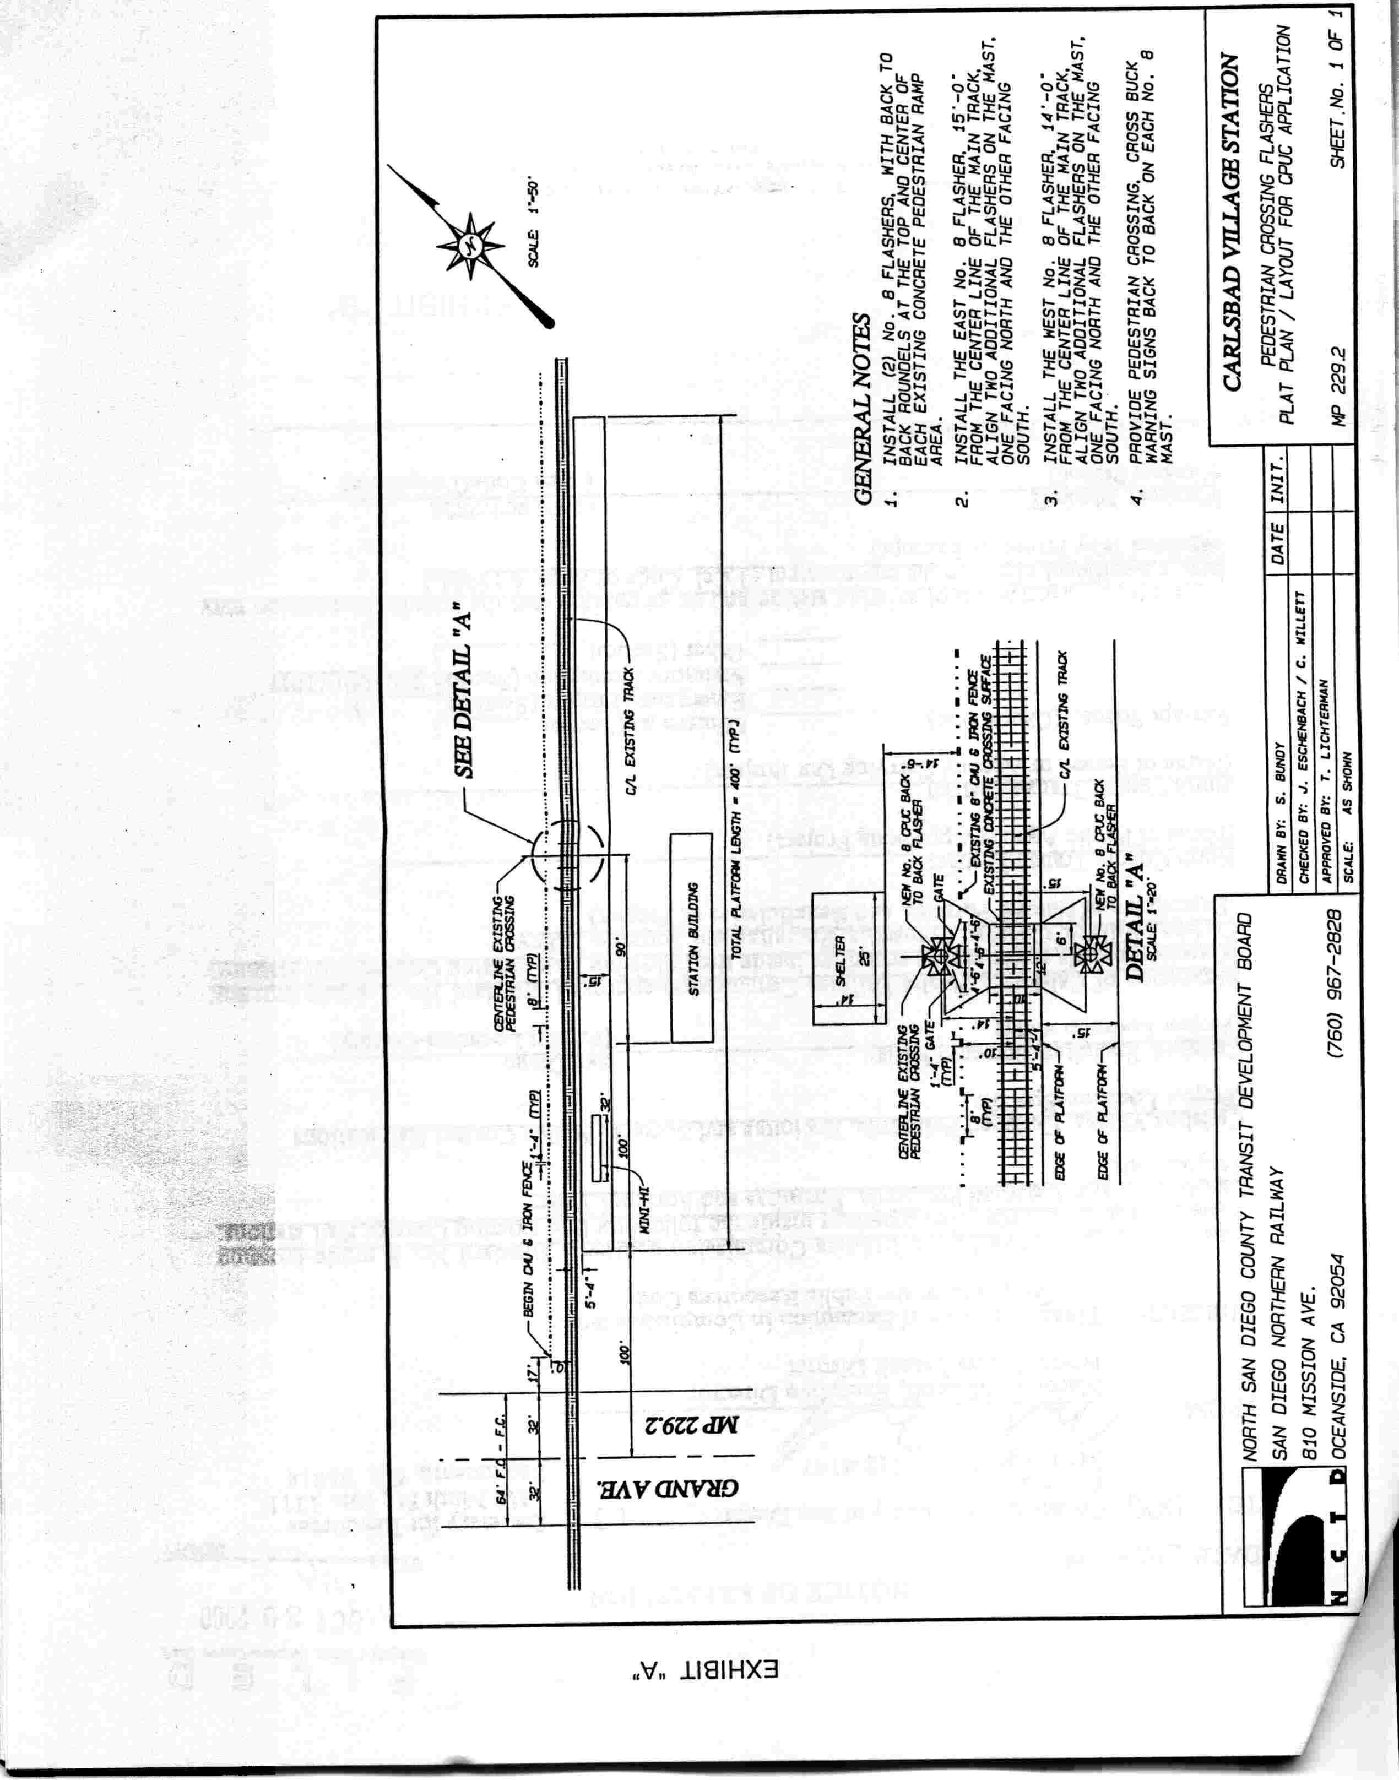

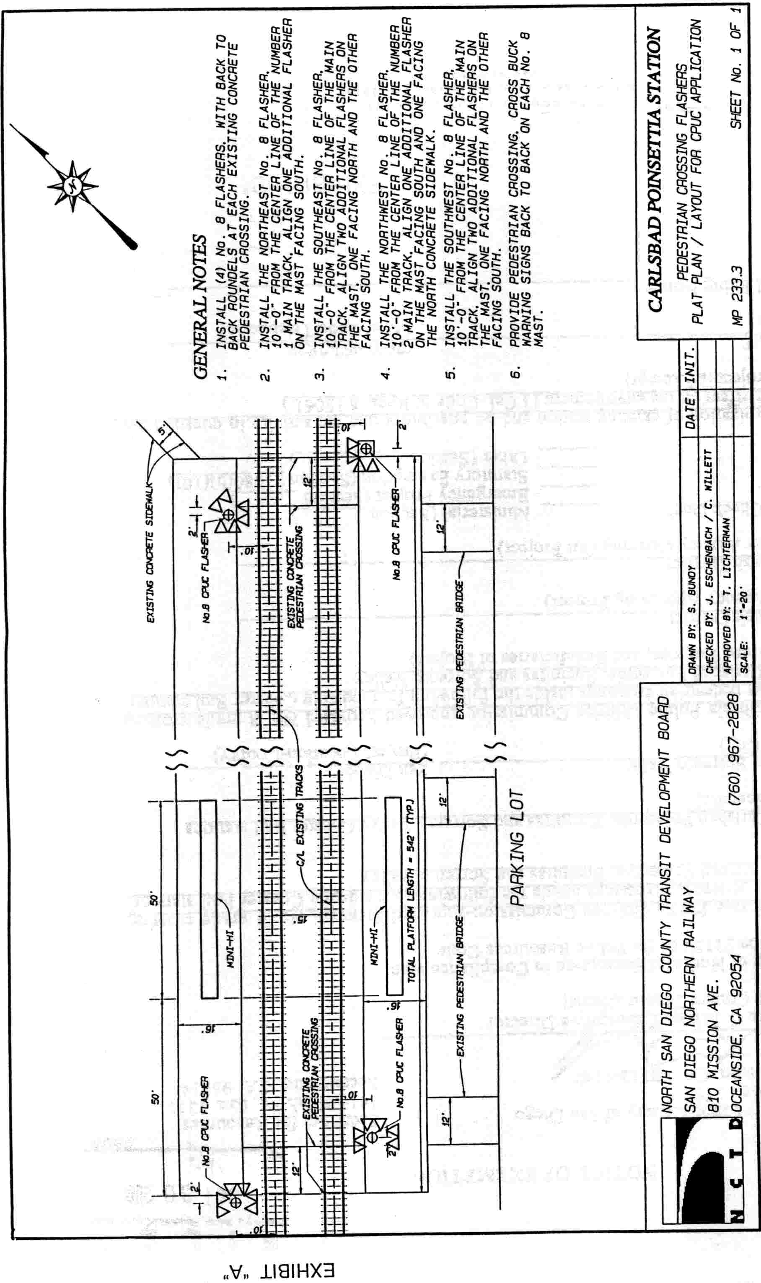

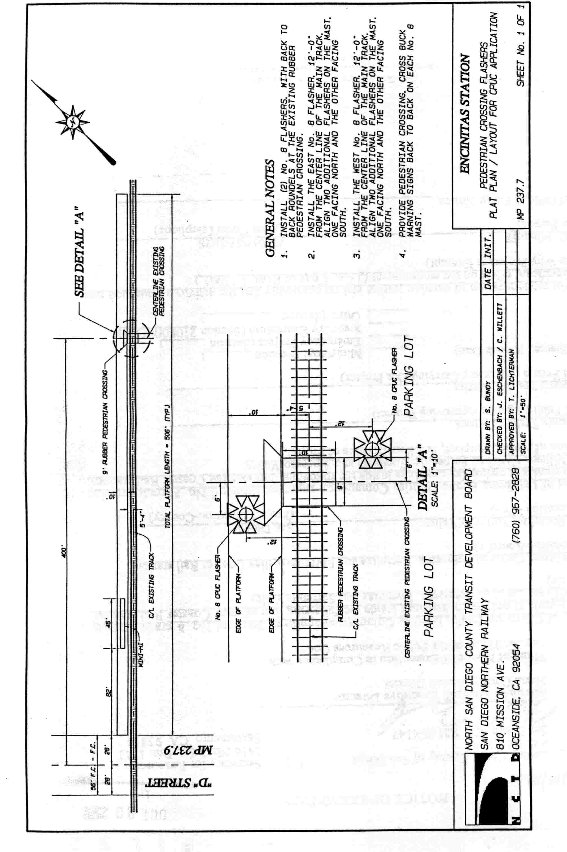

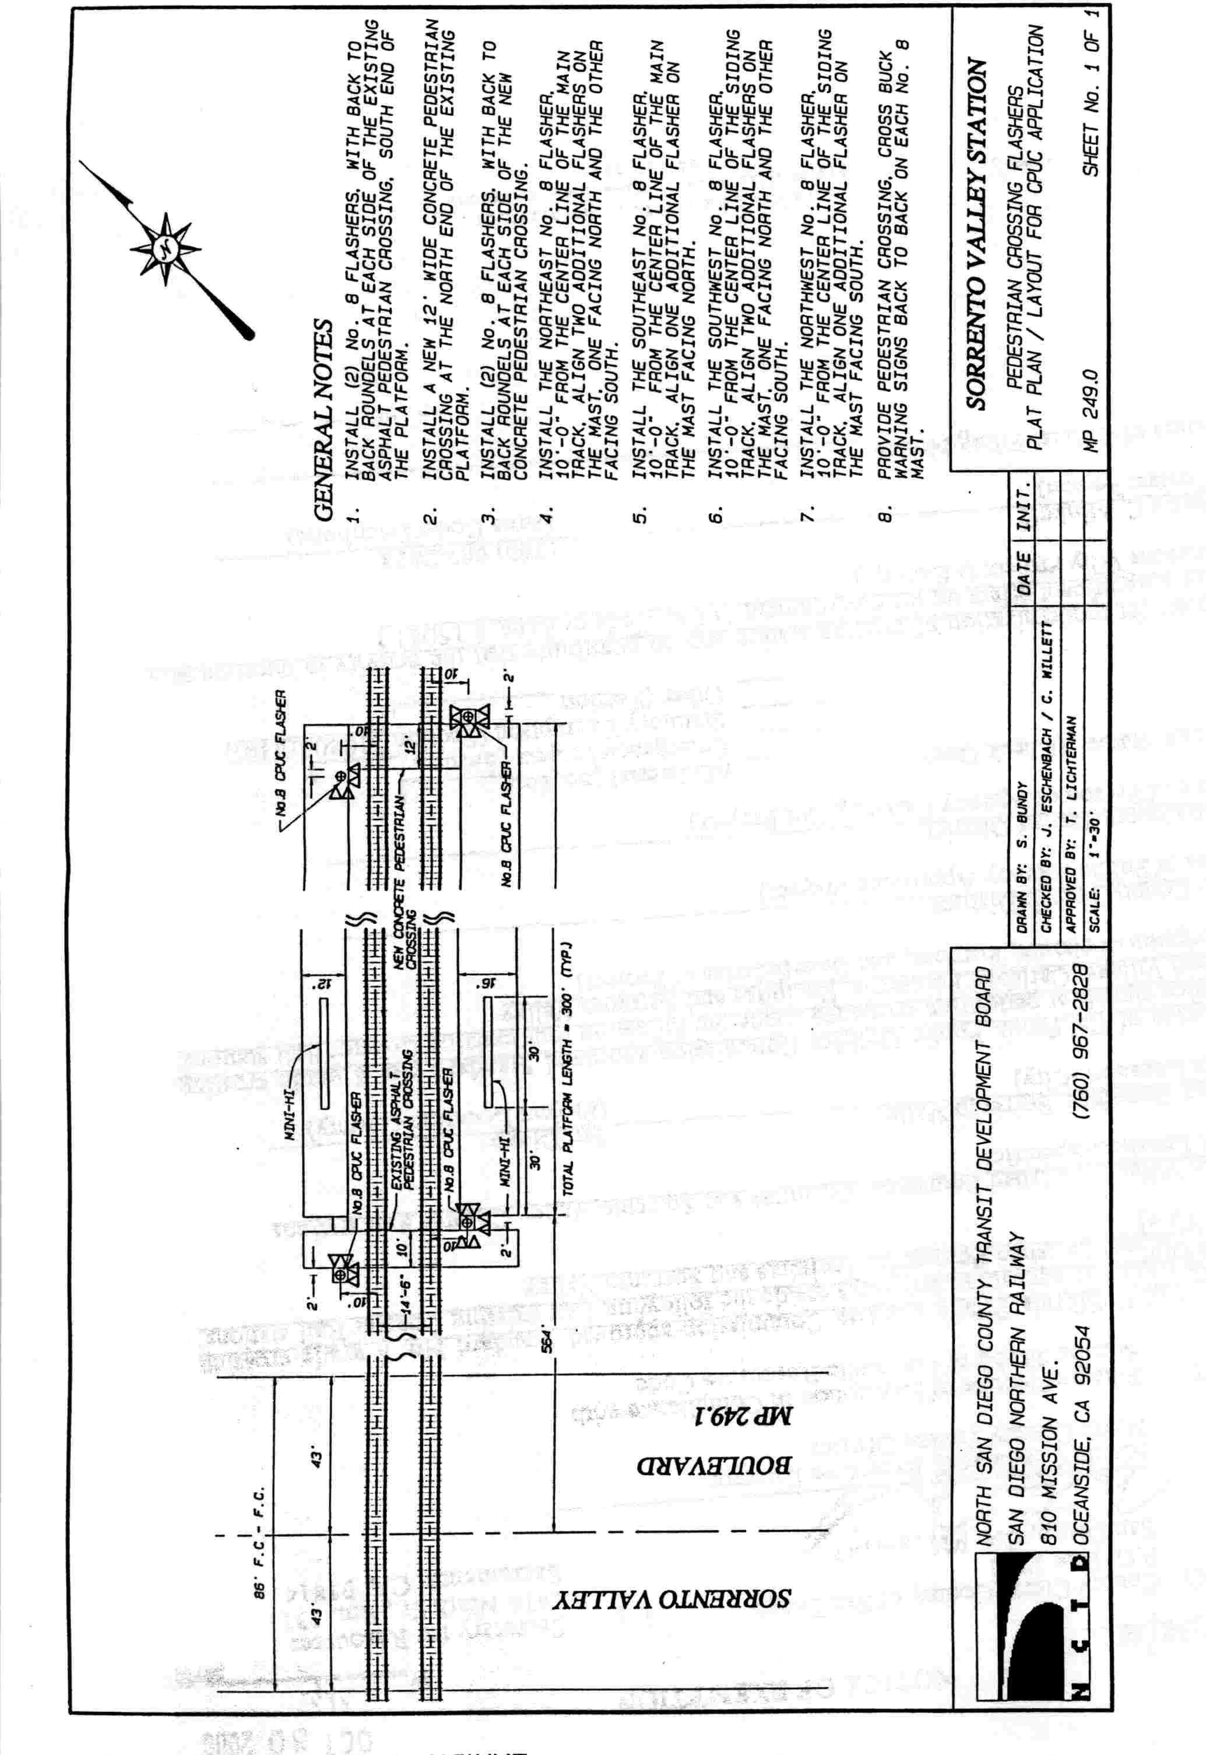

APPENDIX B

As part of a project to enhance safety of existing concrete in-station pedestrian at-grade crossings, The North San Diego County Transit Development Board (NCTD) proposes to install automatic signal warning devices at various commuter rail stations in the cities of Carlsbad, Encinitas and San Diego, all within San Diego County. NCTD requests Commission authority in Applications 01-05-005, 01-05-006, 01-05-007 and 01-05-008. Due to noise concerns raised by communities at some of the station locations, NCTD proposes to use low-tone bells and baffles on the automatic signal warning devices at certain stations to direct sound away from nearby residences. The proposed low-tone bells will meet or exceed the 75-decibel requirements of State and Federal regulations. Public safety requires that the in-station pedestrian at-grade crossings be protected, as stated in the applications and more particularly as set forth below:

1. The Carlsbad Village Commuter Rail Station is located in downtown Carlsbad in a predominately commercial area. The existing in-station pedestrian at-grade crossing is located at milepost 229.15, approximately 300 feet east of the public grade crossing at Grand Avenue Crossing No. 106-229.20, in the City of Carlsbad. Due to the proximity of a neighboring residential community to the station, NCTD proposes to install two PUC Standard No. 8 Flashing light type signals as specified in GO 75-C, with low-tone bells and baffles to direct sound away from the nearby residents. The crossing shall be identified as 106-229.15-D.

2. The Carlsbad Poinsettia Rail Station is located in the City of Carlsbad in a mixed residential/commercial area. There are two in-station pedestrian at-grade crossings. The northern pedestrian crossing is located at milepost 233.18 and the southern pedestrian crossing is located at milepost 233.25. The next public at-grade crossing to the north of the Carlsbad Poinsettia station is Cannon Road in the City of Carlsbad Crossing No. 106-231.40, a distance of approximately 1.6 miles. The next public at-grade crossing to the south is Leucadia Boulevard in the City of Encinitas Crossing No. 106-236.50, a distance of approximately 3.5 miles.
Due to noise concerns raised by residents of the Lanakai Lanes Mobile Home Park, a neighboring community, NCTD proposes to install two PUC Standard No. 8 Flashing light type signals (GO 75-C) with low-tone bells and baffles to direct the noise away from the park. The low-tone bells with baffles were demonstrated to residents of the mobile home park on October 7, 2000 and met with approval. The northern crossing shall be identified as 106-233.18 –D and the southern crossing as 106-233.25-D.

3. The Encinitas Commuter Rail Station is located in downtown Encinitas in a predominantly commercial area. However, there is a large condominium complex approximately 150 feet east across the street from the station. There is one in-station pedestrian at-grade crossing at this station located at milepost 237.80. The next public at-grade crossing to the north is Leucadia Boulevard in the City of Encinitas Crossing No. 106-236.50, a distance of approximately 1.4 miles. The next public at-grade crossing to the south is “D” Street in the City of Encinitas Crossing No. 106-237.90, a distance of approximately 300 feet.
Due to noise concerns raised by residents of the condominium complex across the street from the station, NCTD proposes to install two PUC Standard No. 8 Flashing light type signals (GO 75-C) with low-tone bells and baffles to direct the noise away from the condominium complex. The low-tone bells with baffles were demonstrated to residents of the condominium complex on November 9, 2000 and met with approval. The crossing shall be identified as 106-237.80-D.
In addition, NCTD requests Commission authority, in Application 01-05-007, to deviate from GO 75-C and have the sounding of the automatic warning device low-tone bells stop once the train has entered the Encinitas Commuter Rail Station and occupied the in-station pedestrian at-grade crossing. The pedestrian crossing is the only crossing in the Encinitas station, and when a commuter train has stopped at the station, it occupies the crossing and prevents use of it by pedestrians. NCTD believes that the continued sounding of the automatic warning device bells creates unnecessary and excessive noise.

4. The Sorrento Valley Commuter Rail Station is located in the center of a large industrial area, alongside Sorrento Valley Road and under an Interstate 5 Freeway overpass in the City of San Diego. There are no adjacent residential communities that would be affected by the proposed project.
There is one existing in-station pedestrian at-grade crossing at this station located on the southern end of the station at milepost 248.96. NCTD proposes to install two PUC Standard No. 8 Flashing light type signals (GO 75-C) with low-tone bells, and replace the existing pavement with concrete crossing material. NCTD also proposes to construct an additional in-station pedestrian at-grade crossing with two PUC Standard No. 8 Flashing light type signals (GO 75-C), with low-tone bells and concrete crossing material located on the northern end of the station at milepost 248.91. The next public at-grade crossing to the north is Coast Boulevard in the City of Del Mar Crossing No. 106-244.10, a distance of approximately 5 miles. The next public at-grade crossing to the south is Sorrento Valley Boulevard in the City of San Diego Crossing No. 106-249.10, a distance of approximately 0.20 miles. The northern crossing shall be identified as 106-248.91 –D and the southern crossing as 106-248.96-D.
The table on page 4 lists NCTD’s proposed crossing improvements at each Commuter Rail Station.

Summary of Proposed Work
Application No. | Location | Proposed Work | CPUC Crossing Number | Crossing Protection  G.O. 75 – C
01-05-005 | Carlsbad Village Commuter Station  City of Carlsbad.  MP 229.15. | Install automatic warning signals at one (1) existing pedestrian crossing. | 106-229.15-D | 2 – Standard No. 8 Flashing Light Signals
01-05-006 | Carlsbad Poinsettia  Rail Station  City of Carlsbad.  MP 233.18 and 233.25. | Install automatic warning signals at two (2) existing pedestrian crossings. | 106-233.18-D (northern crossing),  106-233.25-D (southern crossing). | 2 – Standard No. 8 Flashing Light Signals
01-05-007 | Encinitas Commuter  Rail Station  City of Encinitas.  MP 237.80. | Install automatic warning signals at one (1) existing pedestrian crossing. | 106-237.80-D | 2 – Standard No. 8 Flashing Light Signals
01-05-008 | Sorrento Valley Commuter Rail Station  City of San Diego.  MP 248.91 and MP 248.96. | Construct new pedestrian crossing. Install automatic warning signals at one (1) existing and one (1) new pedestrian crossing | 106-248.91 (new northern crossing),  106-248.96-D (southern crossing). | 2 – Standard No. 8 Flashing Light Signals

